Web Service APIs

🌐 Web Service APIs – Overview
# Source: AI Source: Provided by: [Data Path: Persons Table -> ID Column: 1, Name_En Column: Motasem Essam] -> From: [Chatgpt (GPT‑5 Mini)] on [1/19/2026]
A Web Service API is a way for two systems (like a client and a server) to communicate with each other over the internet using a standardized protocol. APIs (Application Programming Interfaces) expose functionalities of an application so that other programs can access them.

✅ Types of Web Service APIs
# Source: AI Source: Provided by: [Data Path: Persons Table -> ID Column: 1, Name_En Column: Motasem Essam] -> From: [Chatgpt (GPT‑5 Mini)] on [1/19/2026]
- REST (Representational State Transfer)
  - Most popular
  - Uses HTTP methods (GET, POST, PUT, DELETE)
  - Returns data typically in JSON or XML
  - Stateless and lightweight
  - 📎 Example: https://api.example.com/users/1
- SOAP (Simple Object Access Protocol)
  - Uses XML only
  - Strict protocol with predefined structure
  - Typically used in enterprise systems
  - Slower and heavier than REST
  - 📎 Example: Uses WSDL (Web Services Description Language)
- GraphQL
  - Developed by Facebook
  - Clients request exactly what they need
  - Single endpoint for multiple data queries
  - Efficient but requires a learning curve
- gRPC (Google Remote Procedure Call)
  - Uses HTTP/2 + Protocol Buffers (not JSON/XML)
  - Very fast and efficient
  - Ideal for internal microservices communication

🔧 Common Web API Methods (HTTP Verbs)
# Source: AI Source: Provided by: [Data Path: Persons Table -> ID Column: 1, Name_En Column: Motasem Essam] -> From: [Chatgpt (GPT‑5 Mini)] on [1/19/2026]


Method | Description
GET | Retrieve data
POST | Submit new data
PUT | Update existing data
DELETE | Delete existing data
PATCH | Partially update existing data

📦 Example REST API (JSON)
# Source: AI Source: Provided by: [Data Path: Persons Table -> ID Column: 1, Name_En Column: Motasem Essam] -> From: [Chatgpt (GPT‑5 Mini)] on [1/19/2026]
Request:
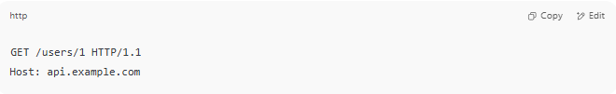
GET /users/1 HTTP/1.1
Host: api.example.com

Response:
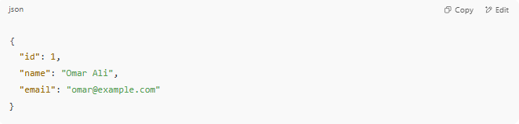
{
"id": 1,
"name": "Omar Ali",
"email": "omar@example.com"
}

🔐 API Authentication Methods
# Source: AI Source: Provided by: [Data Path: Persons Table -> ID Column: 1, Name_En Column: Motasem Essam] -> From: [Chatgpt (GPT‑5 Mini)] on [1/19/2026]
- API Key (simple token in request)
- Bearer Token / OAuth2 (secure and standard)
- Basic Auth (username + password encoded)
- JWT (JSON Web Token) (signed token for identity)

⚙️ Tools for Testing Web APIs
# Source: AI Source: Provided by: [Data Path: Persons Table -> ID Column: 1, Name_En Column: Motasem Essam] -> From: [Chatgpt (GPT‑5 Mini)] on [1/19/2026]
- Postman
- curl
- Insomnia
- Browser (for simple GET requests)

🧠 Examples of Real-World APIs
# Source: AI Source: Provided by: [Data Path: Persons Table -> ID Column: 1, Name_En Column: Motasem Essam] -> From: [Chatgpt (GPT‑5 Mini)] on [1/19/2026]
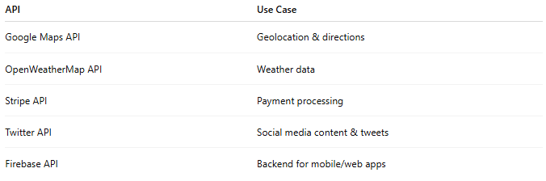

API | Use Case
Google Maps API | Geolocation & directions
OpenWeatherMap API | Weather data
Stripe API | Payment processing
Twitter API | Social media content & tweets
Firebase API | Backend for mobile/web apps

List of popular Web Service APIs
# Source: AI Source: Provided by: [Data Path: Persons Table -> ID Column: 1, Name_En Column: Motasem Essam] -> From: [Chatgpt (GPT‑5 Mini)] on [1/19/2026]
Here’s a list of popular Web Service APIs categorized by their function or industry:

🗂️ 1. General Data & Utility APIs
# Source: AI Source: Provided by: [Data Path: Persons Table -> ID Column: 1, Name_En Column: Motasem Essam] -> From: [Chatgpt (GPT‑5 Mini)] on [1/19/2026]
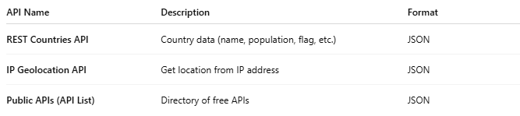

API Name | Description | Format
REST Countries API | Country data (name, population, flag, etc.) | JSON
IP Geolocation API | Get location from IP address | JSON
Public APIs (API List) | Directory of free APIs | JSON

🌤️ 2. Weather APIs
# Source: AI Source: Provided by: [Data Path: Persons Table -> ID Column: 1, Name_En Column: Motasem Essam] -> From: [Chatgpt (GPT‑5 Mini)] on [1/19/2026]
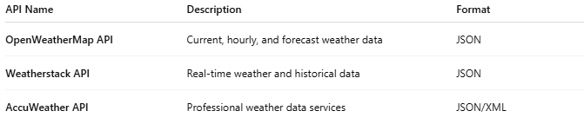

API Name | Description | Format
OpenWeatherMap API | Current, hourly, and forecast weather data | JSON
Weatherstack API | Real-time weather and historical data | JSON
AccuWeather API | Professional weather data services | JSON/XML

📍 3. Maps & Geolocation APIs
# Source: AI Source: Provided by: [Data Path: Persons Table -> ID Column: 1, Name_En Column: Motasem Essam] -> From: [Chatgpt (GPT‑5 Mini)] on [1/19/2026]
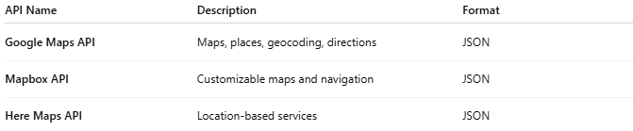

API Name | Description | Format
Google Maps API | Maps, places, geocoding, directions | JSON
Mapbox API | Customizable maps and navigation | JSON
Here Maps API | Location-based services | JSON

💳 4. Payment APIs
# Source: AI Source: Provided by: [Data Path: Persons Table -> ID Column: 1, Name_En Column: Motasem Essam] -> From: [Chatgpt (GPT‑5 Mini)] on [1/19/2026]
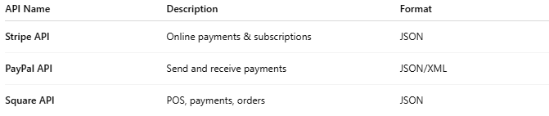

API Name | Description | Format
Stripe API | Online payments & subscriptions | JSON
PayPal API | Send and receive payments | JSON/XML
Square API | POS, payments, orders | JSON

🛒 5. E-commerce APIs
# Source: AI Source: Provided by: [Data Path: Persons Table -> ID Column: 1, Name_En Column: Motasem Essam] -> From: [Chatgpt (GPT‑5 Mini)] on [1/19/2026]
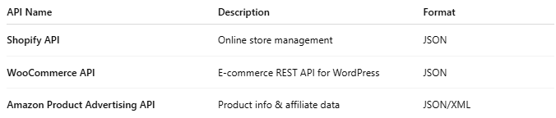

API Name | Description | Format
Shopify API | Online store management | JSON
WooCommerce API | E-commerce REST API for WordPress | JSON
Amazon Product Advertising API | Product info & affiliate data | JSON/XML

💬 6. Messaging & Communication APIs
# Source: AI Source: Provided by: [Data Path: Persons Table -> ID Column: 1, Name_En Column: Motasem Essam] -> From: [Chatgpt (GPT‑5 Mini)] on [1/19/2026]
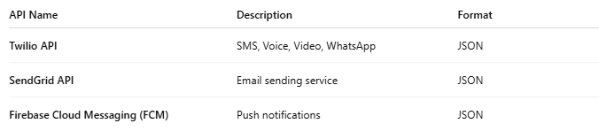

API Name | Description | Format
Twilio API | SMS, Voice, Video, WhatsApp | JSON
SendGrid API | Email sending service | JSON
Firebase Cloud Messaging (FCM) | Push notifications | JSON

🧠 7. AI & NLP APIs
# Source: AI Source: Provided by: [Data Path: Persons Table -> ID Column: 1, Name_En Column: Motasem Essam] -> From: [Chatgpt (GPT‑5 Mini)] on [1/19/2026]
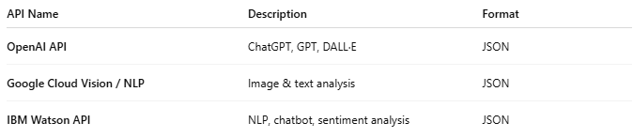

API Name | Description | Format
OpenAI API | ChatGPT, GPT, DALL·E | JSON
Google Cloud Vision / NLP | Image & text analysis | JSON
IBM Watson API | NLP, chatbot, sentiment analysis | JSON

📱 8. Social Media APIs
# Source: AI Source: Provided by: [Data Path: Persons Table -> ID Column: 1, Name_En Column: Motasem Essam] -> From: [Chatgpt (GPT‑5 Mini)] on [1/19/2026]
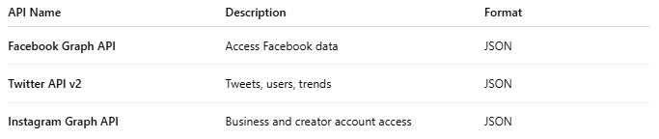

API Name | Description | Format
Facebook Graph API | Access Facebook data | JSON
Twitter API v2 | Tweets, users, trends | JSON
Instagram Graph API | Business and creator account access | JSON

📰 9. News & Media APIs
# Source: AI Source: Provided by: [Data Path: Persons Table -> ID Column: 1, Name_En Column: Motasem Essam] -> From: [Chatgpt (GPT‑5 Mini)] on [1/19/2026]
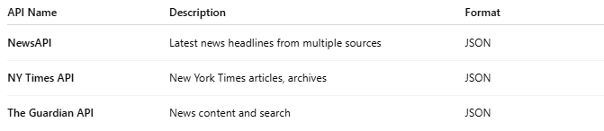

API Name | Description | Format
NewsAPI | Latest news headlines from multiple sources | JSON
NY Times API | New York Times articles, archives | JSON
The Guardian API | News content and search | JSON

🎮 10. Entertainment & Media APIs
# Source: AI Source: Provided by: [Data Path: Persons Table -> ID Column: 1, Name_En Column: Motasem Essam] -> From: [Chatgpt (GPT‑5 Mini)] on [1/19/2026]
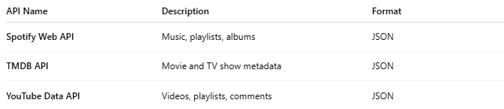

API Name | Description | Format
Spotify Web API | Music, playlists, albums | JSON
TMDB API | Movie and TV show metadata | JSON
YouTube Data API | Videos, playlists, comments | JSON

